DR. AMBEDKAR COLLEGE, DEEKSHABHOOMI, NAGPUR

DEPARTMENT OF LAW

REPORT ON Ph.D ORIENTATION SESSION

Date: 06.07.2023
Name of the Programme: Orientation session for the newly inducted Ph.D Scholars
Number of attendees: 11

NOTICE

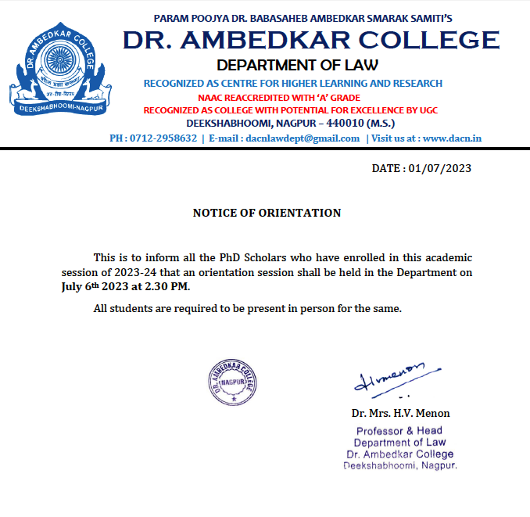

A Ph.D Orientation Program marks the beginning of the journey into the university by the research scholars. The primary purpose of a orientation program is to introduce the doctoral students to the structure and objectives of Ph.D programme under the aegis of RTM Nagpur University.

Keeping this in mind, an Orientation program was conducted for the Ph.D Scholars of 2022-23 batch by the Department of Law, Dr. Ambedkar college, Deekshabhoomi, Nagpur.

Dr. H.V. Menon, Professor and Head of the Department of Law, opened the session by congratuling the newly admitted research scholars and shared some of words of wisdom to apprise the scholars of the nitty gritties of the program. She provided an overview on the structure of the PhD program comprising of the pre-Ph.D course work and encouraged the scholars to figure out the area for research and frame a topic of research with utmost care as this is the only way to reduce the research gap.

Dr. H.V. Menon guided the scholars for the pre-Ph.D coursework wherein the research scholars have to attain 12 credits and suggested them to initially register for the Research Methodology course. She also indicated that even though the courses will be provided by the HR Cell of the RTM Nagpur university, the research scholars can earn credit hours by completing the courses provided by NPTEL under SWAYAM. She also stated that the research papers required as reference to conduct research by the scholars in their respective topics need to be from referred journals only.

She also emphasized that the scholars should be determined to finish their work in stipulated time and gave a presentation on the use of library resources.

Supervisors for Ph.D in the Deparment of Law, Dr. Ambedkar College, Deekshabhoomi, Nagpur - Dr. Mrs. Varsha Deshpande, Dr. Mrs. Sandhya Kalamdhad and Dr. Ms. Pratima Lokhande were present for the session.

